Predict Firsts
- Task 2.2: Predict first: Before you run this test, write down what you expect to happen if you delete your supplier variable (del supplier) after creating the products. Can each Product still display its supplier information? Run it and check. If your prediction did not match, note why.
  - If it is an association relation as it is designed, I expect the Product to not be able to display its supplier information. Because there is no more supplier information to feed Product. I did a test run on this. It works. Then I integrated this onto my main app. Without the supplier, the program renders the Supplier Information as “Unknown Supplier”, as I instructed it to because people are more uncomfortable of voids, it is better to say “Unknown Supplier” than to simply pretend there were no suppliers for that product. I included DigitalProducts and SubscriptionProducts in too because even they need a supplier to supply the data and the subscription
- Task 3.2: Predict first: Before step 3, write down whether you expect the Product to still work after it is removed from Inventory A, and why. Then check
  - I expect Product to still work after it is removed from Inventory A, because while Aggregation is stronger than Association, the 2 objects with whom an Aggregation is shared is still expected to exist independently from each other. To this end, I added a remove function in the main program. I also did a test run on testrun.py, and it is determined to work
- Task 4.3: Predict first: If you add the same Product to two different Orders, how many OrderLine objects and how many Product objects will exist? Write your answer down, then check it (for example, compare objects using is or id()).
  - Did this on Testrun.py. There are 2 OrderLine objects and 1 Product object
  - Are the two OrderLines distinct object instances? True
  - -> OrderLine 1 ID: 1879682463264 | OrderLine 2 ID: 1879683044112

  - Do both independent OrderLines reference the exact same Product object? True
  - -> Referenced Product ID: 1879682462592
  - Since Product ID is the same, but the 2 OrderLine IDs are not, we know 2 OrderLine Objects and 1 Product Object exist
- Task 6.3:
  - Diagnose: A teammate proposes this DigitalProduct method. The program runs until Inventory calls update_stock() on a digital product.
- class DigitalProduct(Product):
def update_stock(self, quantity: int) -> None:
raise NotImplementedError("Digital products have no stock")

  - Does this violate LSP? What would you change: the subclass, the parent class (Product), or the inheritance relationship? Write 2–3 sentences explaining your choice.
  - Yes. Because the function behaves in a way that threatens the program. It essentially refuses to perform its intended role and throws a NotImplementedError instead. Besides, I kept stock on all Product child classes to enforce Liskov
  - I will change it such that it passes. It keeps its other variables, but has no stock functionality. The raise error line to be replaced with just pass
- Task 7.2: Predict first: Before running your test, write down what each product will print for get_fulfilment_info(). Then compare with the actual output.
  - Each product will print the standard info + any specific info for the given Child Class such as download_size for DigitalProduct and duration for SubscriptionClass. The actual output is exactly as predicted. I believed I worked on this in either Lab 7 or 8. SubscriptionProduct was optional, but I added it anyway because I believe in going above and beyond the standards
- Task 8: AI Use: If you use AI, such as your TeamAId AI teammate, to draft or check your diagram, check every relationship it chooses against Section 1. A common mistake, by AI and people, is treating any stored reference as aggregation or composition (for example, supplier: Supplier is an association). Note one thing you accepted and one thing you changed.
  - One common problem I encountered is when I used pyreverse, the UML diagram would not acknowledge any relationship at all, even if I applied abstraction on Product, the diagram would not acknowledge it as an abstract Class. And it often would not even acknowledge the Digital/Subscription/PhysicalProduct as child classes of Product. I had to actually manually write down the abstraction and interface relationships because pyreverse would not acknowledge them
- Reflection
  - Most of my assumptions were correct. But some nuances. The test file ran as expected, but the actual program had some quirks. Including saying unknown supplier, which I preferred to keep as it shows honesty compared to just pretending the supplier does not exist which is false.
  - In my group project, we could use

Documentation
Github repository source: https://github.com/SYnthestic/INF1103lab2

Docker Build Successful | 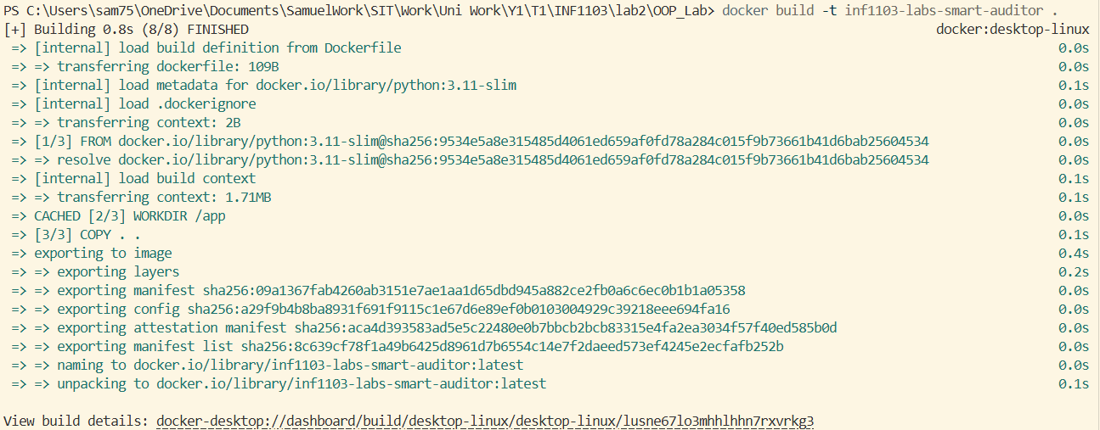
Docker Images | 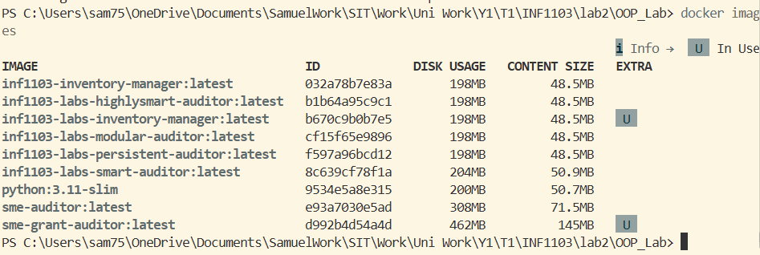
Docker Run Successful | 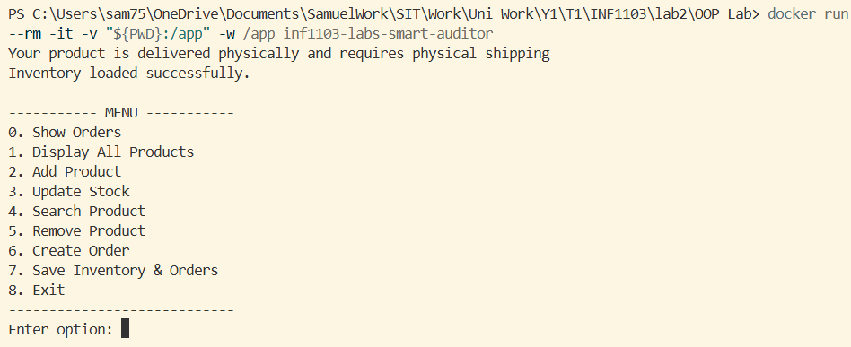
Docker Run – Show all orders | 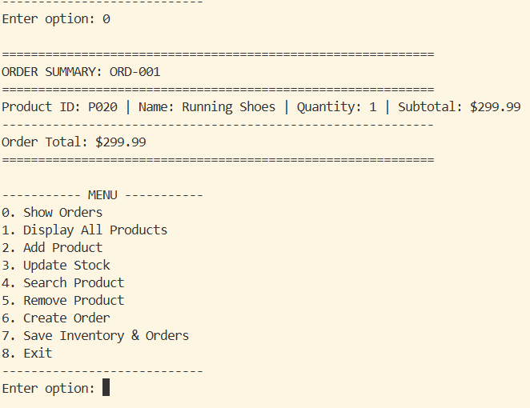
Docker Run – Show all products | 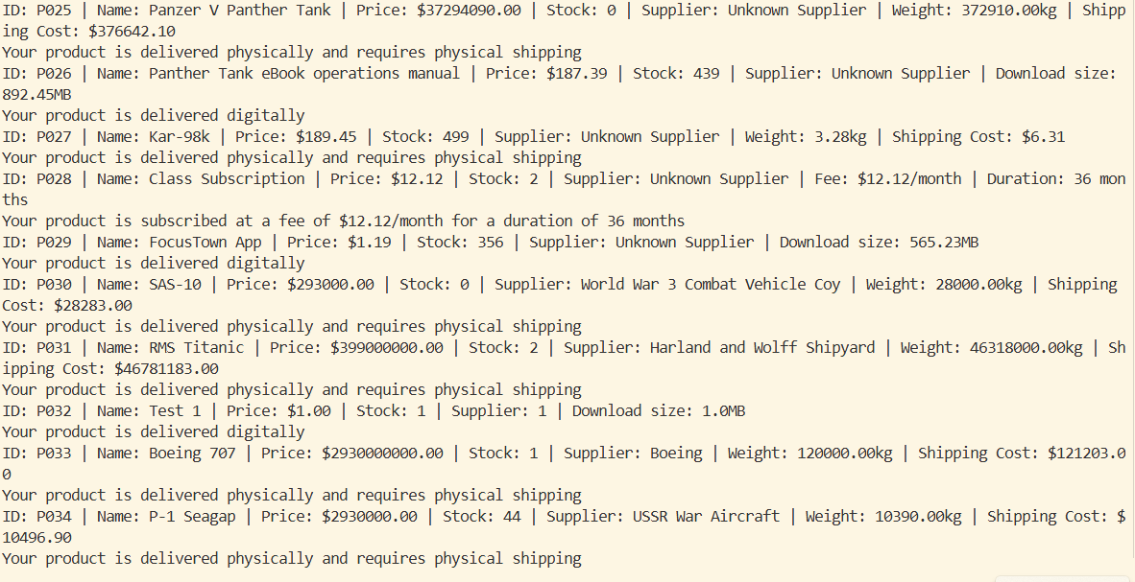
Docker Run – Add product. Physical | 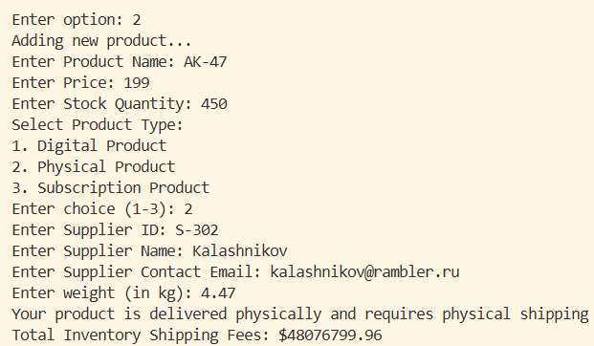
Docker Run – Add product. Digital | 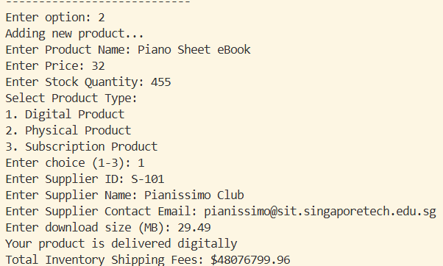
Docker Run – Add product. Subscription | 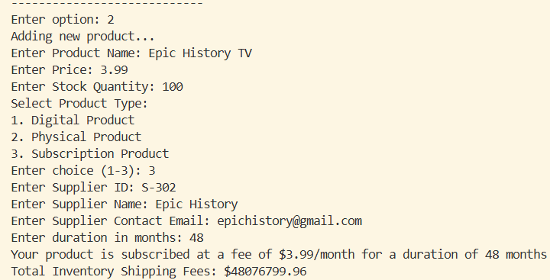
Docker Run – Show all products. With the extra 3 added products | 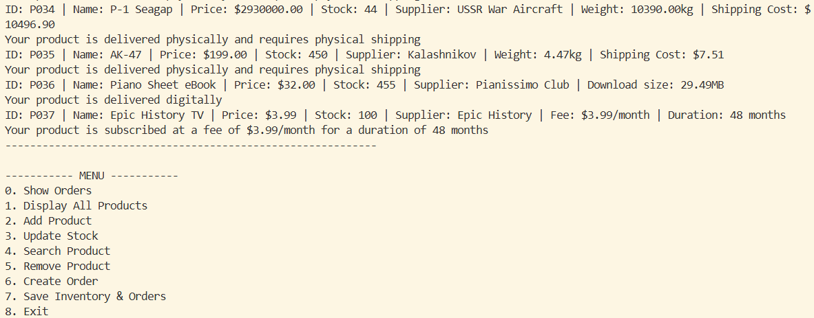
Docker Run – Update Product Stock Success | 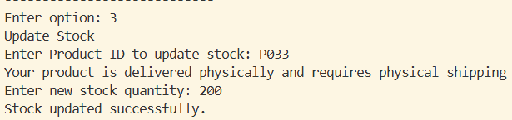
Docker Run – Update Product Stock Product Not Found | 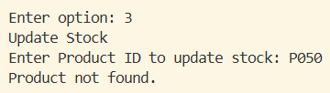
Docker Run – Search Product Success | 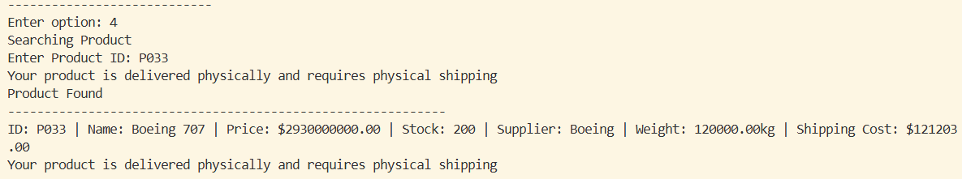
Docker Run – Search Product Not Found | 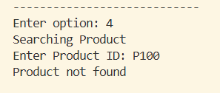
Docker Run – Remove Product Success | 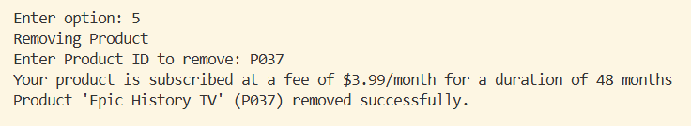
Docker Run – Remove Product Not Found | 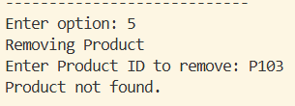
Docker Run – Order Product Success | 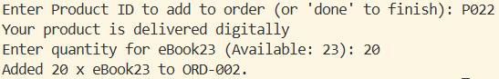
Docker Run – Show Orders after Purchase | 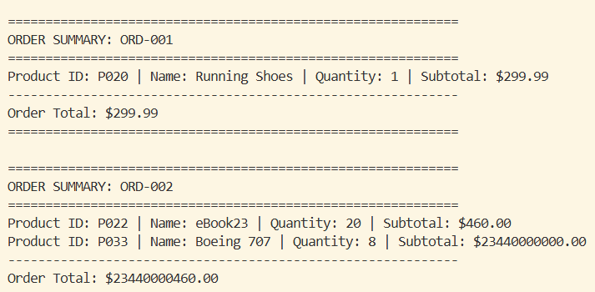
Docker Run – Order Product Not Found
Order Product Insufficient Stock | 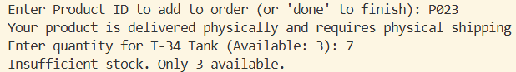
Order Product No Stock Left | 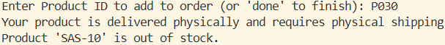
Order Product Invalid Input | 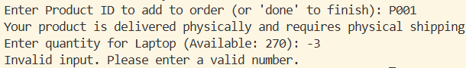
Docker Run – Save Inventory and Orders | 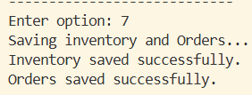
Docker Run – Exit | 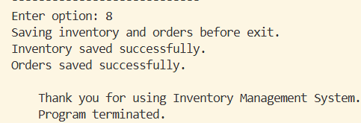
Type Hints – Inventory | 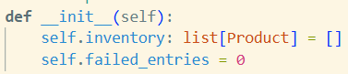
Type Hints – Order | 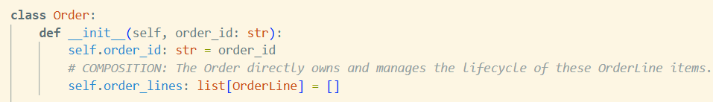
Type Hints – Product | 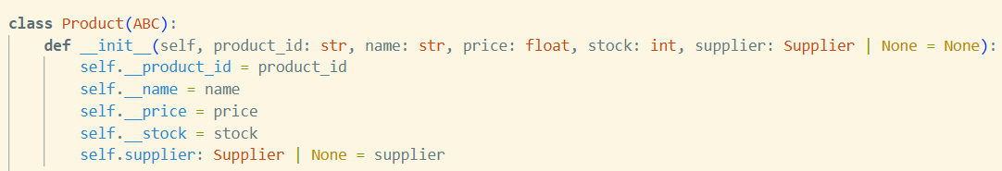
Type Hints – OrderLine | 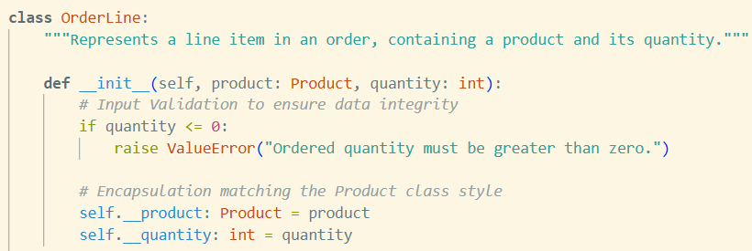
Method Param and Return Type – Inventory.find_product | 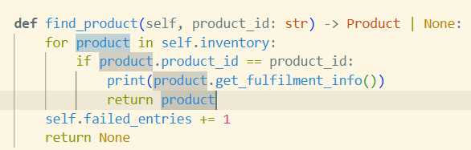
Method Param and Return Type – Inventory.add_product | 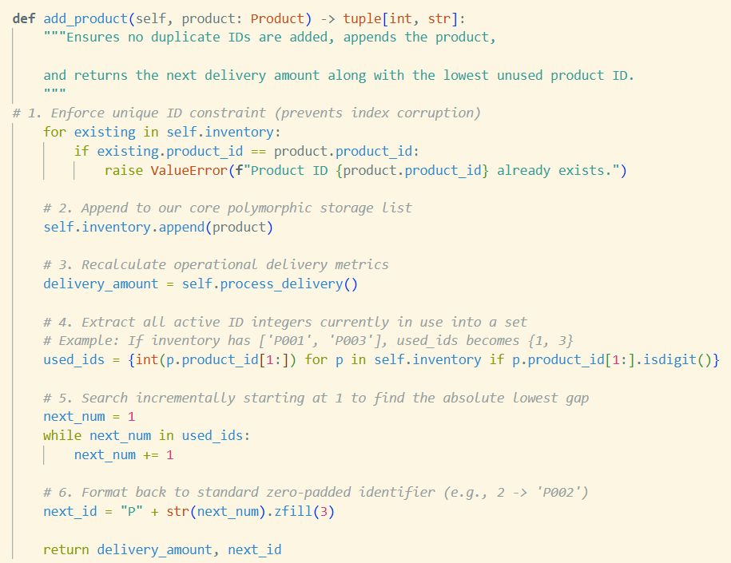
Method Param and Return Type – Order.add_order_line | 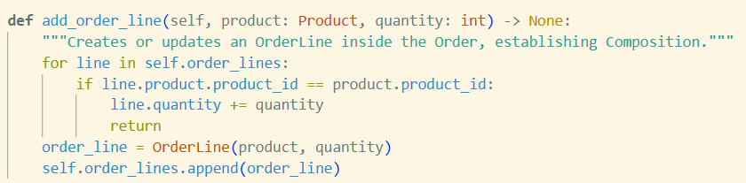
Method Param and Return Type – Order.calculate_total
Method Param and Return Type – OrderLine.calculate_subtotal | 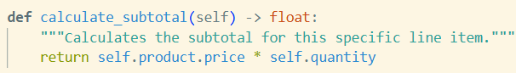
Method Param and Return Type – main.show_product_details | 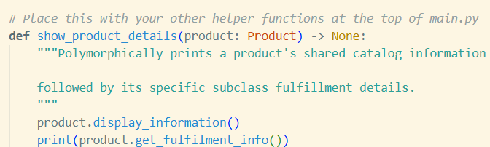
Screenshot of test code showcasing relationships and LSP | 

